TC-AUTH-009
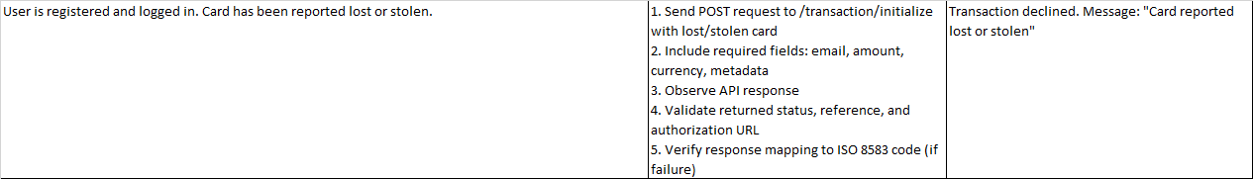
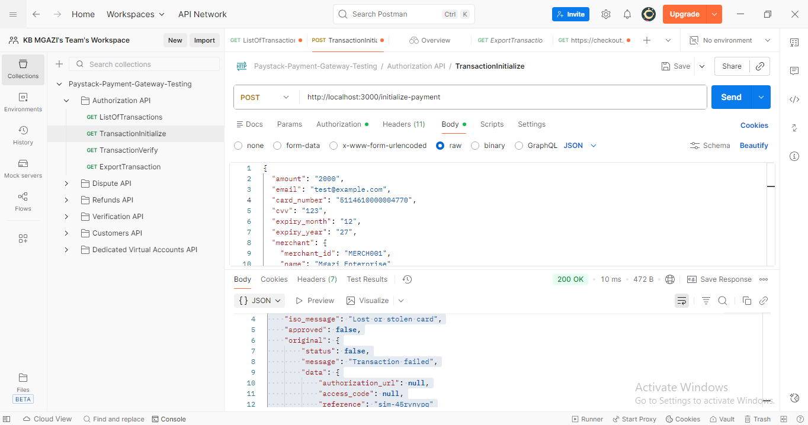
Request:
{
"amount": "2000",
"email": "test@example.com",
"card_number": "5114610000004770",
"cvv": "123",
"expiry_month": "12",
"expiry_year": "27",
"merchant": {
"merchant_id": "MERCH001",
"name": "Mgazi Enterprise"
}
}

Response:
{
"simulation": true,
"iso_response_code": "43",
"iso_message": "Lost or stolen card",
"approved": false,
"original": {
"status": false,
"message": "Transaction failed",
"data": {
"authorization_url": null,
"access_code": null,
"reference": "sim-45rynypq"
}
}
}

